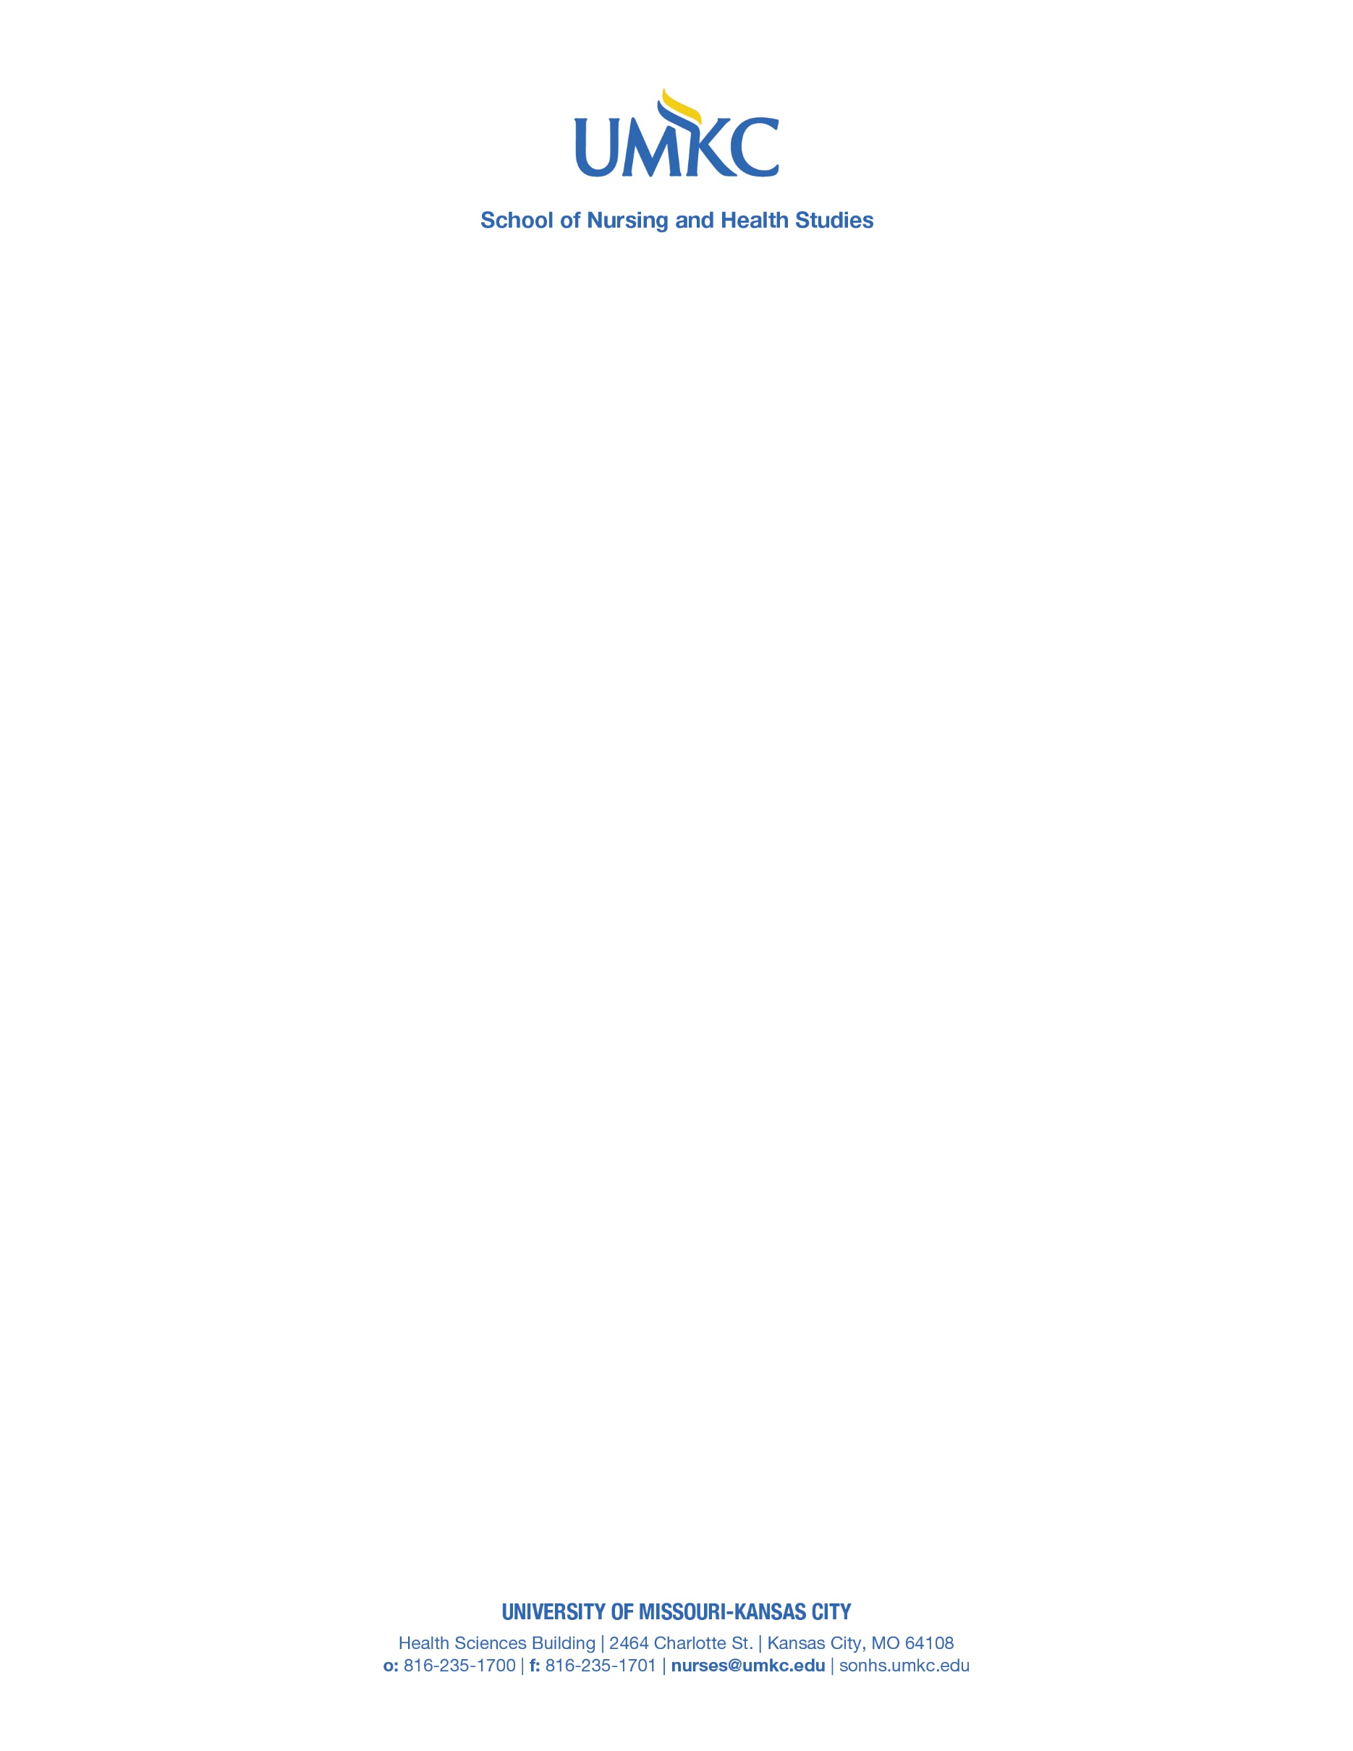

PUBLIC NOTICE OF UPCOMING MISSOURI STATE BOARD OF NURSING ON SITE REVIEW
The University of Missouri-Kansas City (UMKC) School of Nursing and Health Studies (SONHS) Pre-Licensure, Direct Admit, and Accelerated BSN Programs will host an on-site visit with the Missouri State Board of Nursing on April 14 and April 15, 2025. The purpose of this visit is to seek ongoing approval from the Missouri State Board of Nursing.
As part of this process, written comments about the program are welcome and may be submitted electronically or via mail to
Missouri State Board of Nursing
3605 Missouri Boulevard
P.O. Box 656
Jefferson City, MO 65102-0656
nursing@pr.mo.gov
All written comments should be received no later than Friday April 11th, 2025.
We appreciate your participation and support in this important review process.
Sincerely,
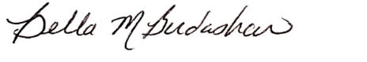
Bella Michelle Birdashaw, DNP, APRN, FNP-C, ENP-C, CCRN
Clinical Associate Professor and Interim BSN Program Director

